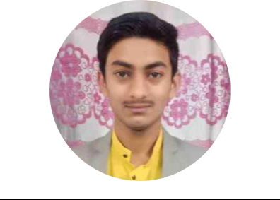

GET IN TOUCH!

Mobile:

+91 - 7218368416

Email:

tushartiwari1501@gmail.com

SKILLS

- Java
- React Js.

- MongoDB

- Node.Js

- HTML

- CSS

- Javascript

- C++
- MySQL

LANGUAGES KNOWN

English ( Both ), Hindi ( Both )

English ( Both ), Hindi ( Both )

CERTIFICATIONS

- Certificate Course in Web Page Designing

- Certificate Course in Database Programming
Tushar Tiwari

PERSONAL DETAILS

Current Location Nagpur

Date of Birth January 15, 2002

Gender Male

EDUCATION

Graduation

Course | B.E. (Computers Science & Engineering)
College | VYWS's Prof Ram Meghe Institute of Technology & Research Badnera,
Amravati
Year of Passing | Graduated in July 2023
Score | 8.95/10
Schooling | Class XII | Class X
Board Name | Maharashtra | CBSE
Medium | English | English
Year of Passing | 2019 | 2017
Score | 66.95% | 68.8%

INTERNSHIPS

Google, India | July 2022 - August 2022

- As demand for skilled Android developers increases in the job marketplace, there is an greater need for the next generation to develop the skills of Android Development.

Forage | July 2022 - August 2022

- Given a Set of Database which Consists of Password of Hash Type && Want to detect those password

Bolt IOT | August 2021 - September 2021

- Created A Web Development Project INVENTROM Website using HTML, CSS & JAVASCRIPT. Learned and Developed more Skills to get about new frame Works.

VERZEO | October 2021 - December 2021

- Developed Static Website with the help of REACTJS Created A Login Form with Help of MONGODB database and also created MERN STACK PROJECT.

PROJECTS

RHYTHM (NFT – Based Music Player in Blockchain)| July 2022 - May 2023
- Developed a Website where an artist can publish his own song and can get more costing value as user can buy and sell the music and they can decide their cost of music which will be listed to others users when the sell it. All these transactions are fully decentralized using blockchain technology.

- KITABIGYAN (REACTJS WITH BACKEND MERN STACK) | September 2021 - December 2021
- Developed A Virtual Notebook In which we can Write Our Notes As we Usually Write Manually And Can Perform CRUD operations.

KHATARNAK TIMES NEWS WEBSITE | June 2021 - July 2021

- Build a News Website made with REACTJS. Handling An External API In REACTJS. Fetching An API and Other Things.

SNAKE GAME(JAVASCRIPT) - Web Development | April 2021 - May 2021

- we have a digital snake that we control using the arrows keys. An fruit randomly appears on the screen and our goal is to move the snake so that it eats the apple.

